* Name of the website or webapp -  **Electronaut (Tinker with Electronics)**
* Type**- Dynamic**

**Features**

* Sign in/Sign Up (Be an Electronaut)
* Badge
* Dashboard of student
* Points earned mention (On Dashboard)

Home

Sign In/Sign Up

Tinker with Electronics

Tinker with Electronics (Click Button)

Background Image

Contact Us -

Mail Id-

Social Media Handles- (Fb,Insta,Twitter, Youtube)

*Guides

*Pinouts

**Dashboard Look-**

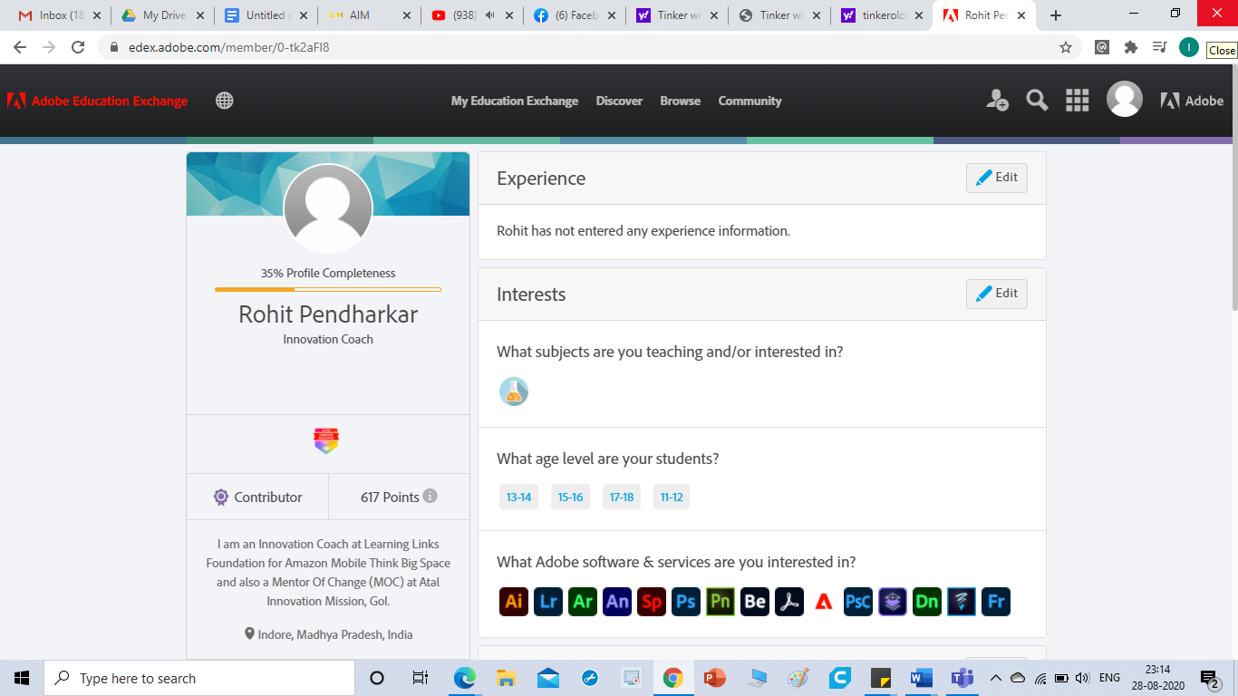

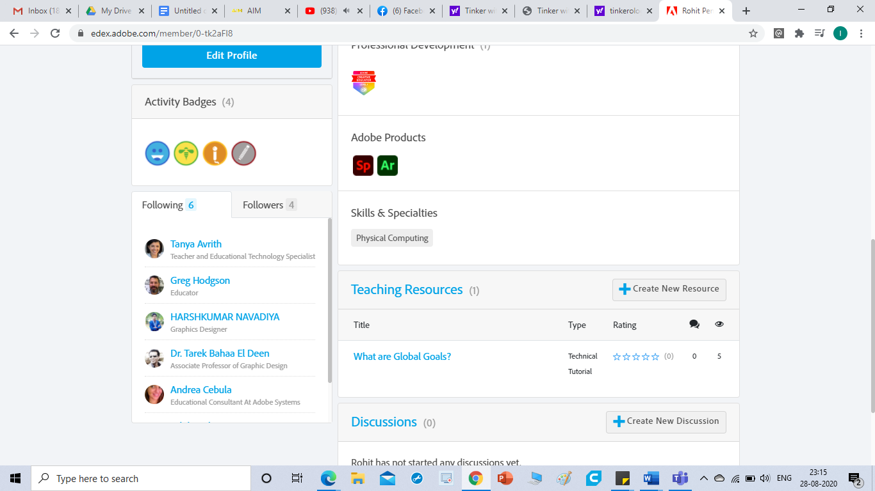

This is important.

Ignore this (no need)

Ignore this (no need)

**Activity Badges-**

**\***Commentator

*Enthusiast

**Note-**

* In the first page when user will click on **“Tinker with Electronics”** button it will redirect to next page.
* When any student completes any activity he will earn some points and he will receive badge and it must be displayed on his dashboard profile.
* I will share the content of Tinker with Electronics page.I am on it.